CHAPTER I
INTRODUCTION

  - Overview
In the serene district of Mehsana, Gujarat, the administrative landscape grapples with a myriad of challenges stemming from the absence of a unified dashboard. The District Collector faces the intricate task of managing and monitoring various projects and schemes spread across diverse departments. Delays in decision-making, difficulties in progress assessment, and challenges in resource allocation become pronounced due to the lack of a consolidated view. Mehsana's administrative processes are at a crossroads, necessitating a transformative solution.
- Absence of a unified dashboard.
- Delays in decision-making.
- Difficulties in progress assessment.
- Challenges in resource allocation.
Changes the Software Can Make:
The introduction of the District Integrated Dashboard promises a revolutionary shift in how Mehsana addresses its administrative challenges. The software serves as a comprehensive solution to the problems plaguing the district. By providing real-time updates on ongoing projects and schemes, the dashboard becomes the cornerstone for informed decision-making. Data visualization tools embedded in the software offer an intuitive comprehension of complex datasets, empowering users with meaningful insights. The integration capabilities ensure a seamless flow of information from various departments, eradicating silos and fostering collaboration.
- Real-time updates on projects.
- Intuitive data visualization tools.
- Seamless integration capabilities.
- Fostering collaboration and transparency.
The imperative for a solution becomes evident as the District Collector strives to enhance governance and overcome administrative bottlenecks. The District Integrated Dashboard emerges as a strategic ally, streamlining monitoring processes, and providing an immediate, consolidated view of ongoing projects. The software empowers decision-makers, facilitates resource optimization, and introduces a new era of efficiency in Mehsana's administrative processes.

  - Problem Statement
District Integrated Dashboard:
As a Head of District Administration, District Collector Don't have any Unified dashboard which gives the Progress details of Different ongoing Project/Schemes of Different Department.
Monitoring, Analyzing and Reviewing of Different Portal and Schemes. A District Integrated Dashboard is a digital tool or platform designed to provide comprehensive and real time information and data on various aspects of a specific district or locality.
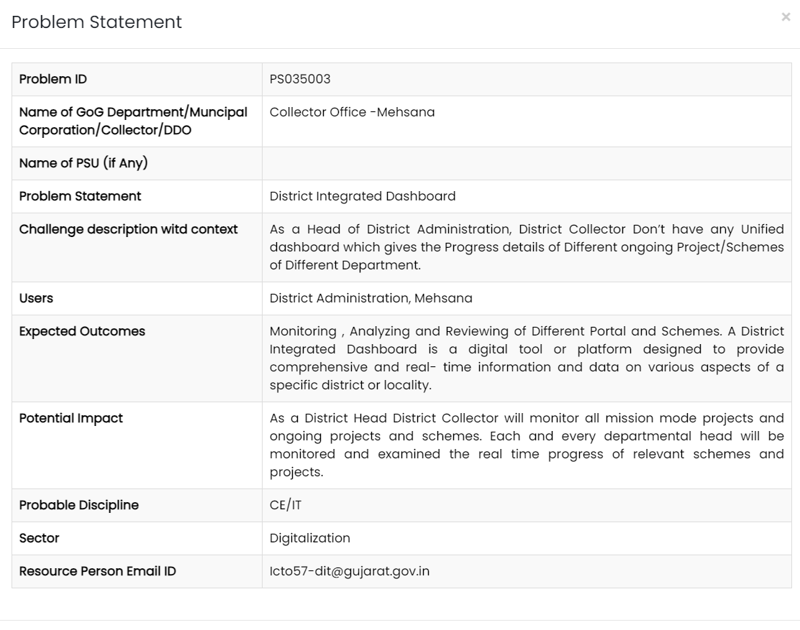
Figure 1 : SSIP problem statement
Website: https://ssipgujarat.in/hackathon2023/problem_statement.php
  - Objective of Project
The overarching objective of the District Integrated Dashboard project is to revolutionize the administrative landscape of Mehsana, Gujarat, by addressing the challenges faced in monitoring and managing various projects across departments. The primary focus is on providing the District Collector and administrative heads with a powerful tool that streamlines monitoring processes, ensures real-time updates on ongoing projects, and enhances decision-making capabilities. The project aims not only to bridge the existing gaps in information flow but to establish a robust and adaptable solution that evolves with the changing dynamics of the district's administrative requirements. The objective is rooted in the vision of creating a digital ecosystem that enhances governance efficiency and transparency.
- Streamline monitoring processes.
- Ensure real-time updates on ongoing projects.
- Enhance decision-making capabilities.
- Bridge existing gaps in information flow.
- Establish a robust and adaptable solution.
- Foster a digital ecosystem for efficient governance.
  - Applications or Scope
The scope of the District Integrated Dashboard project extends far beyond the development of a mere monitoring tool. It envisions a comprehensive application that transforms the way district administration operates in Mehsana. The applications of the dashboard are vast, reaching department heads, project managers, and various administrative officials. By offering transparency, accessibility, and efficiency, the project's scope encompasses not only ongoing projects but also sets a precedent for future initiatives within the district. The software's potential impact is poised to empower users at all levels, creating a dynamic and collaborative environment within the administrative framework.
- Impacting department heads, project managers, and administrative officials.
- Offering transparency, accessibility, and efficiency.
- Setting a precedent for future initiatives.
- Empowering users at all levels.
- Creating a dynamic and collaborative administrative environment.
  - Organization of Report
The organization of the report is structured to provide a comprehensive understanding of the District Integrated Dashboard project. Beginning with an introduction that outlines the problem statement and provides an overview of Mehsana's administrative challenges, the subsequent chapters delve into a thorough literature survey, detailed methodology, and the critical system and hardware requirements. The report then progresses to explore the expected outcomes, featuring a user-friendly GUI, and concludes by outlining the future scope and potential enhancements. Each chapter builds upon the last, creating a coherent narrative that reflects the project's evolution and its potential impact on Mehsana's administrative processes.

CHAPTER II
LITERATURE SURVEY
The comprehensive literature review conducted for the District Integrated Dashboard project has provided valuable insights into the diverse landscape of dashboard implementations across various domains. The selected literature spans a spectrum, from government agencies to pandemic response dashboards, shedding light on both the challenges and advancements in dashboard design, functionality, and implementation. This assimilation of knowledge serves as the bedrock for understanding the intricacies involved in developing an effective and scalable District Integrated Dashboard for Mehsana.
Sr. No. | Paper Title | Author Name | Publish Year | Advantages | Methodology | Deficiency
1 | New India vibrant Hackathon 2023 SSIP report (page 206-207) | PATEL RUDRA JAYESHKUMAR | 2023 | Real-time district project updates, centralized dashboard, improved monitoring & decision-making. | Data consolidation from various departments, inter-departmental collaboration. | Requires data integration effort.
2 | Government agency SMA dashboard | Basyurt A S | 2022 | Well-structured model | Iterative Model | Not scalable  Using API which are not as scalable as to begin with  Bad design
3 | Dashboards in Government | Sukumar Ganapati | 2011 | Enhanced Decision-Making | Waterfall | Lack of emphasis on data security
4 | BI Dashboard utility | Ketan Joshi | 2017 | Well-designed dashboard  Easy to access for government employee | Waterfall model | Public view is not well designed  Not as quick
5 | NB Dash | Paterne Chokki | 2021 | Good matrices choices and data collection  Easy to use  Budget application | Iterative Model | Not viable for large datas  Average design
6 | COVID-19 Dashboard | Véronique L L C Bos | 2021 | Easy to use and information provided was useful as per the times  Stable and scalable | Iterative Model | When stufted from covid phase issues transitioning
7 | DashHov: e-Government Dashboard | Greet Jans | 2006 | easy user access  good Usability and accessibility | Derived Quality model | Not scalable
8. | Enhancing Government Data Portals: A Security Analysis | Gupta Akash | 2017 | Emphasis on data security, Secure authentication | Waterfall | Limited discussion on real-time monitoring capabilities
9 | Real-time Integrated Dashboard for Efficient Road Construction Progress Monitoring | Jawa Anak | 2021 | User-friendly and effective progress monitoring.  Timely detection of deviations from the schedule through daily updates.  Reduction in reporting time and improvement in project controls with real-time integrated dashboards. | (Iterative Development) Combination of quantitative and qualitative approaches.  Questionnaire surveys targeting construction management participants.  Utilization of Relative Important Index (RII) techniques for determining the reliability and merit of responses.  Dashboard development involving programming and User Acceptance Testing (UAT). | Data Integration Challenges  User Adoption Issues  Scalability Issues
10 | An Interactive Dashboard for Tracking COVID-19 in India | Arun Mitra,  Biju Soman, Gurpreet Singh, Achutha Menon Centre for Health Science Studies, SCTIMST, India | 2021 | District-level insights: The dashboard offered detailed information at the district level, allowing for targeted interventions and resource allocation.  Open-source and reproducible: The code and data were openly available, promoting transparency and facilitating further development. | Agile | Limited data for projections: Projections for future cases might have been less accurate for states with fewer cases (<50 cases/day).  Focus on national data: The paper primarily discussed national trends and may not have comprehensively addressed regional variations.
11 | Optimizing Administrative Efficiency through Digital Dashboards | Sidharth Patel | 2018 | Streamlined project monitoring, Increased efficiency | Waterfall | Lack of emphasis on data security
12 | Challenges in Data Integration for Government Projects | Kumar Rao | 2019 | Identified solutions for effective data integration | Agile | Limited practical implementation insights
Table 1: Literature Review Table
Key Learnings:
The literature reveals a recurring theme of challenges faced by diverse dashboards, emphasizing common issues such as scalability, data integration, and security. Many dashboards, including those for government agencies and pandemic response, grapple with the complexities of real-time data integration and efficient monitoring. A notable finding is the recurrent need for enhanced security measures, as demonstrated in studies focusing on data security in government portals. Despite these challenges, the literature review also highlights the advantages and features that successful dashboards possess, providing valuable lessons for the District Integrated Dashboard project.
One common thread identified in the literature is the challenge of scalability. Dashboards, irrespective of their domain, often encounter difficulties in accommodating the growing volume of data and users over time. This recurring issue underscores the importance of designing the District Integrated Dashboard with scalability at its core, ensuring that it can seamlessly evolve with the expanding needs of Mehsana's administrative landscape.
Security emerges as a paramount concern in multiple studies, emphasizing the vulnerability of government data portals. The findings underscore the necessity for robust security protocols within the District Integrated Dashboard to safeguard sensitive information. Implementing state-of-the-art security measures will be imperative to instill confidence in users and uphold the integrity of the data being processed and displayed.
Conversely, the literature also highlights the positive aspects and features that contribute to the success of various dashboards. User-friendly interfaces, effective data visualization tools, and real-time updates emerge as common features in successful implementations. Incorporating these elements into the design and development of the District Integrated Dashboard will be crucial in ensuring its usability, accessibility, and overall effectiveness.

CHAPTER III
METHODOLOGY
  - Background / Overview of Methodology
The methodology adopted for the District Integrated Dashboard project is crucial for its successful development and implementation. It is imperative to understand the background and rationale behind the chosen methodology. The iterative approach was selected due to its suitability for dynamic environments like administrative processes. This methodology emphasizes continuous refinement and adaptation, allowing for incremental development and adjustments based on feedback. Below, we outline the background and overview of the methodology in both paragraph and points format:
- Iterative Approach:
- Allows for continuous improvement and flexibility.
- Facilitates incremental development and adaptation to changing requirements.
- Dynamic Nature of Administrative Processes:
- Administrative processes in Mehsana are subject to frequent changes and updates.
- The iterative methodology aligns well with this dynamic nature, ensuring the dashboard remains relevant over time.
- User-Centric Design:
- Focuses on user feedback and collaboration throughout the development process.
- Ensures that the dashboard meets the specific needs and preferences of Mehsana's administrative ecosystem.
- Continuous Refinement:
- Emphasizes regular review and refinement of features based on user feedback.
- Enables the dashboard to evolve in response to emerging requirements and priorities.
- Adaptability:
- Allows for adjustments and modifications to be made easily as new insights are gained.
- Ensures that the dashboard remains responsive to the evolving needs of Mehsana's district administration.
  - Project Platforms Used in Project
The choice of project platforms is fundamental to the success and effectiveness of the District Integrated Dashboard. It is essential to carefully consider both front-end and back-end technologies to ensure a seamless user experience and robust functionality. Below, we outline the project platforms used in the development of the dashboard, providing insights into their selection and integration:
- Front-end Technologies:
- HTML, CSS, JavaScript, and React.js are utilized for the user interface.
- These technologies ensure an interactive and visually appealing dashboard.
- Back-end Technologies:
- Python serves as the core back-end technology.
- Frameworks like Django or Flask are employed for their scalability, ease of development, and integration capabilities.
- Integration of Front-end and Back-end:
- The combination of front-end and back-end technologies ensures seamless communication and data flow.
- Enables the dashboard to handle complex operations and deliver real-time updates effectively.
- Scalability and Adaptability:
- The chosen technologies are scalable and adaptable to accommodate future growth and changes in requirements.
- They provide a solid foundation for the long-term sustainability of the District Integrated Dashboard.
- User Experience Focus:
- The selection of technologies prioritizes user experience, ensuring that the dashboard is intuitive and easy to use.
- Integrates advanced features for data visualization and interaction to enhance user engagement.
  - Proposed Methodology
The proposed methodology for the development of the District Integrated Dashboard outlines a systematic approach to ensure its successful implementation. It encompasses various phases, each with specific objectives and activities aimed at achieving the project goals. Below, we outline the proposed methodology in detail, highlighting its key components and the rationale behind its selection:
- Comprehensive Analysis Phase:
- Conducts an in-depth analysis of Mehsana's administrative requirements and challenges.
- Identifies key stakeholders and gathers user feedback to inform the development process.
- Development of Core Functionalities:
- Focuses on developing essential features and modules based on the analysis conducted.
- Prioritizes functionality that addresses critical administrative needs and enhances decision-making processes.
- Regular Feedback Sessions:
- Incorporates regular feedback sessions with end-users to validate and refine the dashboard's features.
- Ensures that the dashboard meets the specific needs and preferences of Mehsana's administrative ecosystem.
- Iterative Refinement:
- Emphasizes an iterative development approach, allowing for continuous refinement and adaptation.
- Enables the dashboard to evolve over time in response to changing requirements and priorities.
- User-Centric Design:
- Places a strong emphasis on user experience and usability throughout the development process.
- Ensures that the dashboard is intuitive, easy to navigate, and meets the needs of its target audience.
  - Project Modules
The District Integrated Dashboard is structured into distinct modules, each designed to address specific aspects of administrative monitoring and project management. These modules encompass essential functionalities that collectively contribute to the overall effectiveness of the dashboard. Below, we outline the project modules in detail, highlighting their key features and contributions to the dashboard's functionality:
- Real-time Updates Module:
- Provides timely dissemination of critical information and updates on ongoing projects and schemes.
- Enhances the responsiveness of the dashboard and enables quick decision-making by district administrators.
- Data Visualization Module:
- Offers intuitive data visualization tools to enhance comprehension and analysis of complex datasets.
- Enables users to gain actionable insights from the data presented on the dashboard.
- Integration Capabilities Module:
- Facilitates the aggregation of data from disparate sources and departments within the district.
- Ensures a comprehensive overview of administrative processes and project progress.
- User Management Module:
- Provides varying access levels and permissions to different user roles within the district.
- Enables effective collaboration and ensures data security and privacy.
- Accessibility Module:
- Ensures a seamless and inclusive user experience across different devices and accessibility requirements.
- Adheres to accessibility standards and guidelines to reach a broader audience within the district.
  - Diagrams

